**MINI-PROJECT - II**

**(2020-2021)**

**Smart Parking System**

(Internet of Things)

**PROJECT MID-TERM REPORT**

**Department of Computer Engineering & Applications**

Institute of Engineering & Technology



**Team Members:**

Harshit Verma Prateek Dubey

(181500260) (181500494)

Harshita Katara Shivam Samadhiya

(181500263) (181500760)

***Supervised By:-***

**Mr. Amir Khan Sir**

(Senior Technical Trainer)

**Certificate**

## This is to certify that Prateek Dubey, Harshit Verma, Harshita Katara, and Shivam Samadhiya students of B.Tech (CSE) 3rd year has successfully Completed the **MINI PROJECT - II** named **Smart Parking System** on Internet of Things (IOT) under the Guidance of Mohd**. Amir Khan** during 2020-21.

**Signature:**

**Mohd.Amir Khan**

(Senior Technical Trainer)

**ACKNOWLEDGEMENT**

First and foremost, we would like to thank our mentor of this project Mohd.Amir Khan Sir for his valuable guidance and advice. He guided us greatly to work on this project. His willingness to motivate us helped tremendously. Besides, we would like to thank the authority of GLA University for providing us with a good environment and facilities to complete this project. Finally, and honourable mention goes to our families and friends for their understanding and support in completing this project. Without help from those mentioned above, this project could not have been completed.

**Prateek Dubey** (181500494)

**Harshit Verma** (181500260)

**Harshita Katara** (181500263)

**Shivam Samadhiya** (181500740)

**Mini-Project Synopsis**

Project Information:

|  |  |
| --- | --- |
| Title of Project | Smart Parking System |
| Technology Used | * Internet of Things * Web Development * Machine Learning |
| Technical Details | **Hardware Requirements :**   * Infra-Red (IR) sensors * LED Lights * Personal Computer * LCD Display * Servo Motor * LDR Module * Connecting Wires * Arduino Uno * Raspberry Pi (Mini-Computer) * Raspberry Pi Camera Module   **Software Requiremnts :**   * **APPLICATION SOFTWARE** * Arduino IDE (Version 1.8.13) * Raspbian OS: A free Debian-based OS optimized Pi’s with all basic programs and utilities we expect from a general-purpose operating system. * **WEB TECNOLOGY** * HTML * CSS * **SERVER** * Firebase (Backend) |

**Contents**

|  |  |
| --- | --- |
| **Abstract** …………………………………………………… |  |
| 1. **Introduction**…………………………………………    1. General Introduction of the topic………………...    2. Area of Computer Science……………………….       1. Internet of Things.       2. Web Development. |  |
| 1. **Problem Definition**…………………………………. |  |
| 1. **Objectives**.................................................................. |  |
| 1. **Software & Hardware Requirement Analysis**……    1. Activity Diagram    2. DFD |  |
| 1. **Implementations Details**…………………………… |  |
| 1. **Some Screenshots**………………………………….. |  |
| 1. **References**………………………………………...... |  |

**Abstract:**

With the increase in vehicle production and world population, more and more parking spaces and facilities are required. In today’s technological world the concept of smart city has become an area of interest. Concern to parking impending in an urban area. The parking space problem can be turn into a new opportunity brought by the recent trends to meet the world’s connected continuum. In the past, there have been many works done on smart parking system approaching an even smarter system in where researches have been done and still being done to create a system which is not technologically savvy but also at ease. This project makes easy for the user to find automatically a free space at the low cost and without consuming time and fuel. The WebApp is also provided to user to check the availability of free space for parking. This project is aimed to create a system that helps people with personal vehicles to find for parking easily. Both software and hardware platform have been developed in this system.

This system uses ultrasonic sensors to detect either vehicle park occupancy or not. Features of Smart Parking System include vacant parking space detection, display of available parking spaces, and directional indicators toward vacant parking spaces, through the use of specific LEDs.

We implemented a full-fledged prototype system for parking management to realize the design functionalities and features mentioned. Our preliminary test results show that the performance of this i.e. internet of thing IOT based system can effectively satisfy the needs and requirements of existing parking hassles thereby minimizing the time consumed to find vacant parking lot, real-time information rendering.

**1. Introduction**

**1.1 General Introduction of the topic**

Currently, most of the existing car parks do not have a systematic system. Most of them are manually managed and a little inefficient. The problem that always occurs at the car park is time being wasted in searching for the available parking spaces. Users will keep on circling the parking area until they found a vacant parking slot. This problem usually occurs in urban areas, where number of vehicles is higher as compared to the availability of parking spaces. These ineffective conditions happened because of the lack of implementation in technologies which are available in the market today. In this current era of modern world, almost everyone owns a personal vehicle and it has become a basic need for the humans. Hence, it has been proven statistically that the usage of vehicles is increasing rapidly yearly. Due to the growth, it is very difficult to find parking slots in cities, especially during the peak time.

This creates a necessity to introduce an automated system that allows users to see their spot just by making a few clicks through a custom made Web Application. This serves to hassle free situation for each and every users.

The development of this project prototype can act as way-finder to guide car driver inside the car park to parking slot available inside car park and guides car driver to go there. It is a Raspberry Pi, Arduino microcontroller based project. It uses the infrared sensor to detect the vacancy of each parking slot at a level of car park, sending signal wireless to microcontroller to process and display total of available parking slot on 16x2 LCD displays. At the same time, it also displays the locations of the empty parking spaces inside Web-based Application.

This project is developed based on the research in existing parking system at the crowded parking area such as shopping complex or mall. Knowing that some parking areas are hard to find an available parking lots, this project is purposely build to solve the problem. This project focus on finding the best way to guide drivers and vehicle’s users to get a free parking lot in short of time Smart Parking System can inform the drivers which parking zones are available and the number of free parking space so that they can make good decision about where they wish to park, and thus find the free parking conveniently.

**1.2 Area of Computer Science**

**1.2.1 Internet of Things**

The internet of things, or IOT, is a system of interrelated computing devices, mechanical and digital machines, or people that are provided with unique identifiers ([UIDs](https://internetofthingsagenda.techtarget.com/definition/unique-identifier-UID)) and the ability to transfer data over a network without requiring human-to-human or human-to-computer interaction.

An IOT ecosystem consists of web-enabled smart devices that use embedded systems, such as processors, sensors and communication hardware, to collect, send and act on data they acquire from their environments. IOT devices share the sensor data they collect by connecting to an IOT gateway or other edge device where data is either sent to the cloud to be analyzed or analyzed locally. Sometimes, these devices communicate with other related devices and act on the information they get from one another. The devices do most of the work without human intervention, although people can interact with the devices -- for instance, to set them up, give them instructions or access the data. The connectivity, networking and communication protocols used with these web-enabled devices largely depend on the specific IOT applications deployed. IOT can also make use of artificial intelligence (AI) and machine learning to aid in making data collecting processes easier and more dynamic.

The internet of things helps people lives and work smarter, as well as gain complete control over their lives. In addition to offering smart devices to automate homes, IOT is essential to business. IOT provides businesses with a real-time look into how their systems really work, delivering insights into everything from the performance of machines to supply chain and logistics operations.

IOT enables companies to automate processes and reduce labour costs. It also cuts down on waste and improves service delivery, making it less expensive to manufacture and deliver goods, as well as offering transparency into customer transactions.

As such, IOT is one of the most important technologies of everyday life, and it will continue to pick up steam as more businesses realize the potential of connected devices to keep them competitive.

**Description of some devices used in this project:**

1. **Infra-Red Sensors:** An **infrared sensor** is an electronic device that emits in order to sense some aspects of the surroundings. An **IR sensor** can measure the heat of an object as well as detects the motion. These types of **sensors** measure only **infrared** radiation, rather than emitting it that is called a passive **IR sensor**.

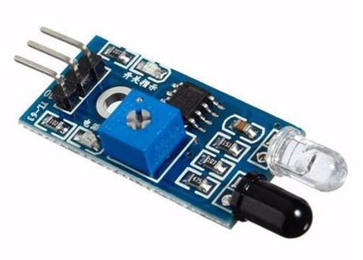

1. **LED Lights:** A light-emitting diode is a semiconductor light source that emits light when current flows through it. Electrons in the semiconductor recombine with electron holes, releasing energy in the form of photons.

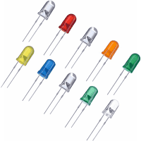

1. **LCD Display:** An **LCD** (**Liquid Crystal Display**) **screen** is an electronic **display** module and has a wide range of applications. A **16x2 LCD display** is very basic module and is very commonly used in various devices and circuits. A **16x2 LCD** means it can **display** 16 characters per line and there are 2 such lines.

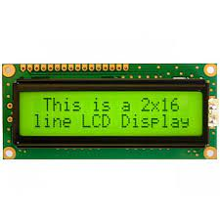

1. **Servo motor:** A **servo motor** is a type of **motor** that can rotate with great precision. Normally this type of **motor** consists of a control circuit that provides feedback on the current position of the **motor** shaft; this feedback allows the **servo motors** to rotate with great precision.

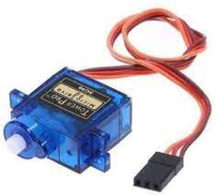

1. **LDR Module:** The **LDR** Sensor **Module** is used to detect the presence of light / measuring the intensity of light. The output of the **module** goes high in the presence of light and it becomes low in the absence of light. The sensitivity of the signal detection can be adjusted using potentiometer.

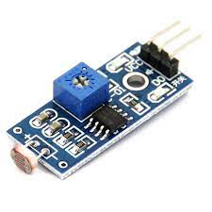

1. **Connecting Wires: Connecting wires** provide a medium to an electrical current so that they can travel from one point on a circuit to another. In the case of computers, **wires** are embedded into circuit boards to carry pulses of electricity.

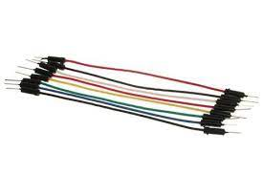

1. **Arduino Uno: Arduino Uno** is a microcontroller board based on the ATmega328P ([datasheet](http://ww1.microchip.com/downloads/en/DeviceDoc/Atmel-7810-Automotive-Microcontrollers-ATmega328P_Datasheet.pdf)). It has 14 digital input/output pins (of which 6 can be used as PWM outputs), 6 analog inputs, a 16 MHz ceramic resonator (CSTCE16M0V53-R0), a USB connection, a power jack, an ICSP header and a reset button. It contains everything needed to support the microcontroller; simply connect it to a computer with a USB cable or power it with a AC-to-DC adapter or battery to get started.

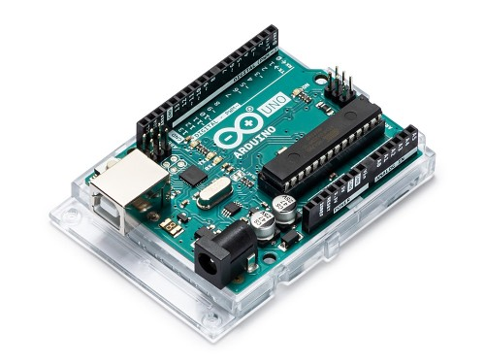

1. **Raspberry Pi:** The Raspberry Pi is a low cost, **credit-card sized computer** that plugs into a computer monitor or TV, and uses a standard keyboard and mouse. It is a capable little device that enables people of all ages to explore computing, and to learn how to program in languages like Scratch and Python. It’s capable of doing everything you’d expect a desktop computer to do, from browsing the internet and playing high-definition video, to making spread sheets, word-processing, and playing games.

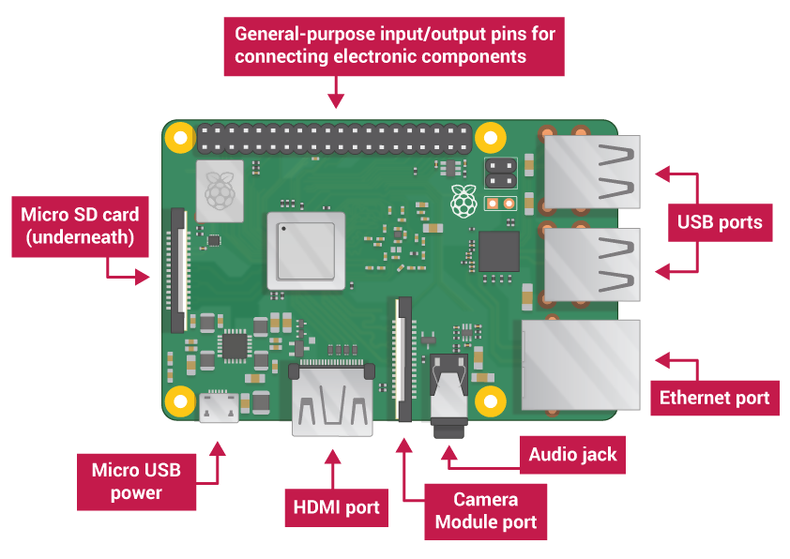

1. **Raspberry Pi Camera Module:** The **Pi camera module** is a portable light weight **camera** that supports **Raspberry Pi**. It communicates with **Pi** using the MIPI **camera** serial interface protocol. It is normally used in image processing, machine learning or in surveillance projects.

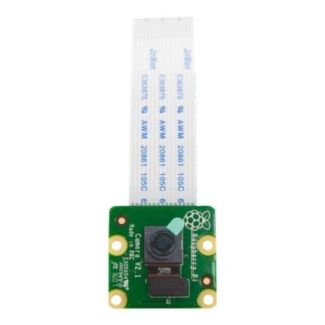

**1.2.2 Web Development**

[Web development](https://openclassrooms.com/en/paths/141-web-developer) is the building and maintenance of websites; it’s the work that happens behind the scenes to make a website look great, work fast and perform well with a seamless user experience. The **HyperText Mark-up Language** or **HTML** (**H**yper**T**ext **M**arkup **L**anguage) is the standard [markup language](https://en.wikipedia.org/wiki/Markup_language) for documents designed to be displayed in a [web browser](https://en.wikipedia.org/wiki/Web_browser). It can be assisted by technologies such as [Cascading Style Sheets](https://en.wikipedia.org/wiki/Cascading_Style_Sheets) (CSS) and [scripting languages](https://en.wikipedia.org/wiki/Scripting_language) such as [JavaScript](https://en.wikipedia.org/wiki/JavaScript).

[Web browsers](https://en.wikipedia.org/wiki/Web_browser) receive HTML documents from a [web server](https://en.wikipedia.org/wiki/Web_server) or from local storage and [render](https://en.wikipedia.org/wiki/Browser_engine) the documents into multimedia web pages. HTML describes the structure of a [web page](https://en.wikipedia.org/wiki/Web_page) [semantically](https://en.wikipedia.org/wiki/Semantic_Web) and originally included cues for the appearance of the document.

[HTML elements](https://en.wikipedia.org/wiki/HTML_element) are the building blocks of HTML pages. With HTML constructs, [images](https://en.wikipedia.org/wiki/HTML_element#Images_and_objects) and other objects such as [interactive forms](https://en.wikipedia.org/wiki/Fieldset) may be embedded into the rendered page. HTML provides a means to create [structured documents](https://en.wikipedia.org/wiki/Structured_document) by denoting structural [semantics](https://en.wikipedia.org/wiki/Semantics) for text such as headings, paragraphs, lists, [links](https://en.wikipedia.org/wiki/Hyperlink), quotes and other items. HTML can embed programs written in a [scripting language](https://en.wikipedia.org/wiki/Scripting_language) such as [JavaScript](https://en.wikipedia.org/wiki/JavaScript), which affects the behaviour and content of web pages. Inclusion of CSS defines the look and layout of content.



We have designed a dynamic website to display all the data entries, number of parking slots available, time at which the user’s vehicle enter into the parking and based on the time duration we calculate the total charges he/she has to pay for the parking.

**2. Problem Definition**

Nowadays most of the car parks require user’s initiative to search for empty space to park their car. This will cause problems when it is too many cars and it makes them wasting their time and energy. One of the factors that contribute to this problem is because of lack of information that given at parking lot. So, one system has to be design to solve this parking problem which will include the information interface criteria.

Nowadays in most of the countries, Parking Information and Guidance (PGI) system have been put into practice in Europe, United State, Japan, and China. Number of cars on the road is increasing while parking spaces are becoming increasingly scarce. Usually during school break or holiday, the numbers of cars that use the parking space in the shopping complex become higher compared to during working day. This will make the parking space become full and the driver need to drive slowly in order for them to check for the free space parking in the shopping complex. This is time consuming and people will become more impatient. Besides that, there are also problems of the parking space which are located far from the entering zone or the building or destination. This situation makes the drivers to choose the nearest parking space as they do not want to walk far.

As the fuel price is keep increase nowadays, users will try their best to save their vehicle energy. At the peak hour, they need to wait for a long time at the entrance gate before they can find the empty parking space. So the users will waste their time and energy to find a free space. Last but not least, the major issue of the parking system is the insufficient parking spaces provided for the user. This may cause by the improper planning by developers of the places. When the parking bay is on its peak hour, the user will search the parking space at the same area again and again before they found it, only if they are lucky. Sometimes, the car park management did not put a notice that the area was full and no more space for parking.

**3. Objectives**

The objectives of this research project are as follows: -

1. To design an automatic parking system that provides information of empty parking spaces in the indoor parking area and design Lighting System and save the energy for in lighting by using Light Dependent Resistors (LDRs) when any one moving inside the garage at night the lighting system will ON.
2. To develop a prototype of smart parking system using Arduino and Raspberry Pi micro controller, sensors and WebApp application.
3. To evaluate the performance of developed prototype to provide information and facilitate the users to the location of empty parking spaces and calculate the parking bill from the time when vehicle enter into the Parking Space to the when vehicle leave exit the parking space over WebApp.

**4. Software & Hardware Requirement Analysis**

**4.1 Data Flow Diagram**

**Zero-level DFD**

This is the Zero Level DFD of Online Car Parking System, where we have elaborated the high level process of Car Parking. It’s a basic overview of the whole Online Car Parking System or process being analyzed or modeled. It is designed to be an at-a-glance view of Parking Fees, Car owner and car Number showing the system as a single high-level process, with its relationships to external entities of Car, Parking Space and Parking Fees in zero level DFD of Online Car Parking System.

Vehicle Management

Parking Space Management

Parking Management

**This project is completed till Zero-level DFD**

Zero Level DFD – Smart Parking System

Login Management

System User Management

Parking Slots Management

5. Half-Implementation Details

Raspberry Pi and Arduino will control the complete process and also send the parking availability information to dynamic web page with Google firebase as backend with the help of REST API so that it can be monitored from anywhere in the world over the internet. IR sensors are used at entry and exit gate to detect the presence of car and automatically open or close the gate. IR Sensor is used to detect any object by sending and receiving the IR rays. Servos will act as entry and exit gate and they rotate to open or close the gate. Finally sensor is used to detect if the parking slot is available or occupied and send the data to microcontroller accordingly.

When car is comes, driver see the LCD screen that is fixed before the barrier of the parking this LCD 16*2 display the vacant parking slot .if there is no parking slot is available then it display 0 slot and our parking barrier (connect to the IR sensor and servo motor that is connect to the Raspberry Pi) cannot open in this condition. If there is vacant space is available then barrier is open and car is enter in parking .in each parking slot there is a IR sensor that detect car is available in the slot or not and display combine data of all IR sensor on LCD screen and display the data on computer screen. We use pair of LEDs in each slot that are connect to IR sensor in that particular Slot through Arduino Uno that display whether if slot is vacant then it glow green otherwise red. This system is fixed all parking slot and display all the data on computer screen or LCD screen. When car is going outside of parking then gate is open with the help of IR sensor and servo motor. there are using 2 street light this is fully automatic in this street light we are using led strip and LDR sensor (that detect the light)and battery.

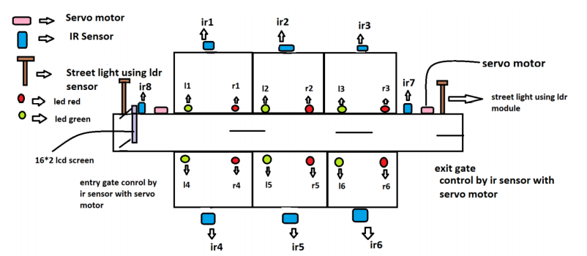

S

Data Flow Diagram

Start

* c

Space is occupied by car and sends to the computer

Space is occupied by car and sends to the computer

Space is occupied by car and sends to the computer

All Parking Spaces are Full

Space is vacant and sends the data to the computer

Space is vacant and sends the data to the computer

IR sensor 2

IR sensor 1

No parking space is free barrier will not open

IR Sensor detect object and servo motor rotate and get will open (gate 1 Entry Gate)

LCD Display Showing Parking Space

Flow Diagram of Smart Parking System